**ASSIGNMENT 4**

|  |  |
| --- | --- |
| **Date** | **14 November 2022** |
| **Team ID** | PNT2022TMID38017 |
| **Project Name** | **Project -**IoT based safety gadget for child safety monitoring and notification |
| **Maximum Marks** | **4 Marks** |

Project Title**:** IoT based safety gadget for child safety monitoring and notification

**Team ID:**PNT2022TMID38017

**QUESTION:**

**Write code and connections in wokwi for ultrasonic sensor. Whenever distance is less than 100 cms send "alert" to ibm cloud and display in device recent events.**

# CODE:

#include <WiFi.h> #include

<PubSubClient.h>

void callback(char* subscribetopic, byte* payload, unsigned int payloadLength);

//-------credentials of IBM Accounts------

#define ORG "Ashfaq1824"//IBM ORGANITION ID

#define DEVICE_TYPE "ESP32"//Device type mentioned in ibm watson IOT Platform #define DEVICE_ID "12345"//Device ID mentioned in ibm watson IOT Platform #define TOKEN "12345678" //Token

String data3;

char server[] = ORG ".messaging.internetofthings.ibmcloud.com"; char publishTopic[] = "iot-2/evt/Data/fmt/json";

char subscribetopic[] = "iot- 2/cmd/test/fmt/String"; char authMethod[]

= "use-token-auth"; char token[] = TOKEN;

char clientId[] = "d:" ORG ":" DEVICE_TYPE ":" DEVICE_ID;

WiFiClient wifiClient;

PubSubClient client(server, 1883, callback

,wifiClient); const int trigPin = 5; const int echoPin = 18;

#define SOUND_SPEED 0.034

long duration; float

distanc e; void setup()

{

**Serial**.begin(115200); pinMode(trigPin, OUTPUT);

pinMode(echoPin, INPUT);

wificonnect(); mqttconnect();

}

void loop()

{

digitalWrite(trigPin, LOW); delayMicroseconds(2); digitalWrite(trigPin, HIGH); delayMicroseconds(10); digitalWrite(trigPin, LOW); duration = pulseIn(echoPin, HIGH);

distance = duration * SOUND_SPEED/2;

**Serial**.print("Distance (cm): "); **Serial**.println(distance); if(distance<100)

{

**Serial**.println("ALE RT!!");

delay(1000); PublishData(distanc e); delay(1000);

if (!client.loop())

{mqttconnect();

}

}

delay(1000);

}

void PublishData(float dist)

{mqttconnect(); String payload =

"{\"Distance\":"; payload

+= dist;

payload += ",\"ALERT!!\":""\"Distance less than 100cms\""; payload += "}"; **Serial**.print("Sending payload: "); **Serial**.println(payload);

if (client.publish(publishTopic, (char*) payload.c_str())) {

**Serial**.println("Publish ok");

} else {

**Serial**.println("Publish failed");

}

}

void mqttconnect()

{ if (!client.connec ted())

{ **Serial**.print("Reconnecting client to ");

**Serial**.println(server);

while (!!!client.connect(clientId, authMethod, token)) {

**Serial**.pri nt(".");

delay(50 0);

}initManagedDevice();

**Serial**.println();

}

}

void wificonnect()

{

**Serial**.println(); **Serial**.print("Connecting to "); WiFi.begin("Wokwi-GUEST", "", 6);

while (WiFi.status() != WL_CONNECTED)

{delay(500);

**Serial**.print(".");

}

**Serial**.println(""); **Serial**.println("WiFi connected"); **Serial**.println("IP address:

");

**Serial**.println(WiFi.localIP ());

}

void initManagedDevice() {

if (client.subscribe(subscribetopic))

{ **Serial**.println((subscribetopic)); **Serial**.println("subscribe to cmd OK");

} else {

**Serial**.println("subscribe to cmd FAILED");

}

}

void callback(char* subscribetopic, byte* payload, unsigned int payloadLength)

{

**Serial**.print("callback invoked for topic: ");

**Serial**.println(subscribetopic);

for (int i = 0; i < payloadLength; i++) {

//Serial.print((char)payl oad[i]); data3 += (char)payload[i];

}

**Serial**.println("data: "+ data3); data3="";

}

# SCHEMATIC/CIRCUIT DIAGRAM:

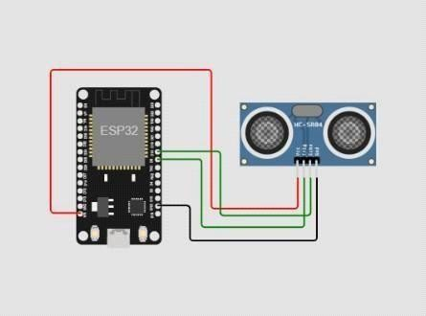

IBM CLOUD OUTPUT:

